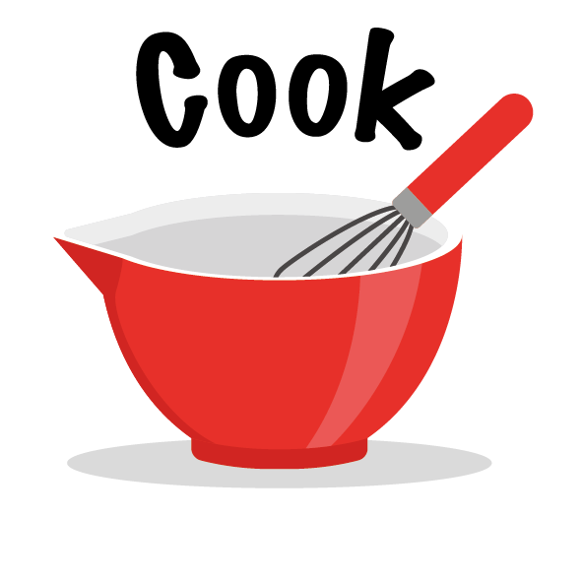

Make a Fabulous Fruit Salad
Challenge | Make a super healthy fruit salad for the whole family.  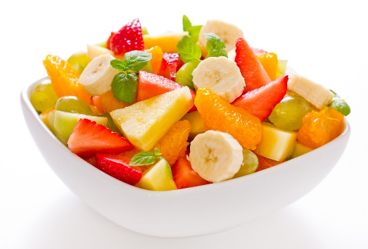  Food skills  - Measure.  - Peel.  - Slice.  - Combine and mix.
Ingredients | - 2 satsumas  - 4 strawberries  - 8 seedless red grapes, halved lengthways  - 8 seedless white grapes, halved lengthways  - 2 bananas  - 2 x 15ml spoons orange juice
Method | - Peel the satsumas and separate into segments.  - Pull the stalks from the strawberries and cut into slices.  - Peel the bananas and cut into slices.  - Place all the fruit in the bowl and add orange juice.  - Mix all the ingredients together.

We’d love to see all the great learning your children are doing at home. A way to share this with our community is to take a photo of your child's work and tag us at q1ehomelearning - this is on either Twitter or Instagram.

