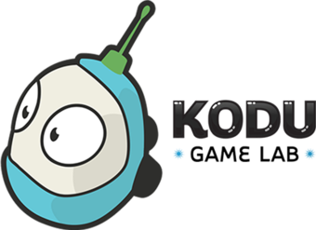

Challenge | Why just play video games when you can create your own?!  - Invent new worlds and create fantastic computer games using Kodu, which teaches you how to code using simple visual programming tools.
Resources | - With a parent’s permission, download Kodu here.  - You can find extra resources and tutorials here.  - Use the ‘Videos getting Started’ or ‘Tips and Tricks’ if you want to.
Extra | - Can you create a game in a new world?  - How about a racing game?

We’d love to see all the great learning your children are doing at home. A way to share this with our community is to take a photo of your child's work and tag us at q1ehomelearning - this is on either Twitter or Instagram

