Wider Curriculum
Unit Plan for Home learning
Subject: History |  | Unit: Life Changers: How can individuals change our lives? | Year: 2
Session
Session 1 | Why are people remembered?  - Throughout history there are people who change the lives of others – sometimes they make lives better and sometimes they make lives worse.  - Sometimes these people are remembered with statues and paintings, or stories. In this country, some people are remembered on bank notes.  - What do you notice about the people who have been remembered on bank notes? Look at the pictures and read the facts in Resource 1. Write your thoughts down in Resource 2.
Session 2 | How did Joseph Bazalgette change the lives of Londoners?  - Have a look at the sources (the pictures and writing from the time) in Resource 3. What problem did London have?  - Have a look at the sources (the pictures and writing from the time) in Resource 4. How did Bazalgette fix the problem?  - Create a poster explaining how Joseph Bazalgette changed London.
Session 3 | How did Florence Nightingale change the lives of soldiers and nurses?  - Have a look at the sources (the pictures and writing from the time) in Resource 5. What problem did hospitals in the Crimea have?  - Have a look at the sources (the pictures and writing from the time) in Resource 6. How did Florence Nightingale help fix the problem?  - Write a letter home as a nurse, or soldier, from Scutari Hospital. Describe the changes you have seen.
Session 4 | Why should we remember Mary Seacole?  - Watch this video about the life of Mary Seacole.  - Mary Seacole was forgotten after the Crimean War – but in 20XX a new statue of her was placed in London.  - Using Resource 7 – write a letter to a friend telling them why we should remember Mary Seacole.
Session 5 | What achievements deserve to be remembered?  - We have looked at only three people from the Victorian Era who changed the world for the better, but many other people have done similar or greater things throughout history.  - Make a poster celebrating the person you think we should remember most.
Session 6 | Who do you think should be remembered?  - At the start of this unit we looked at the people remembered on our bank notes for their achievements.  - Not everyone gets remembered this way, and some people think the choices are unfair – everyone has their own idea about who should be remembered.  - If you could design a banknote for a great life changer, who would you choose? Use Resource 9 to create your own banknote for that person. Explain why you have chosen them. Who knows – maybe one day you will be on a banknote!

Resource 1

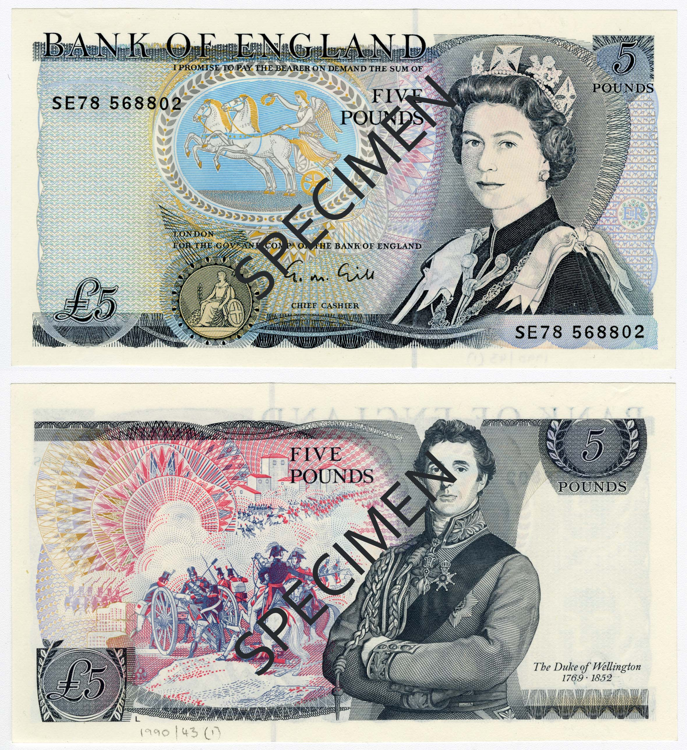
The Duke of Wellington was a soldier and general in the British Army. He commanded British soldiers in a war against France and became Prime Minister afterwards.
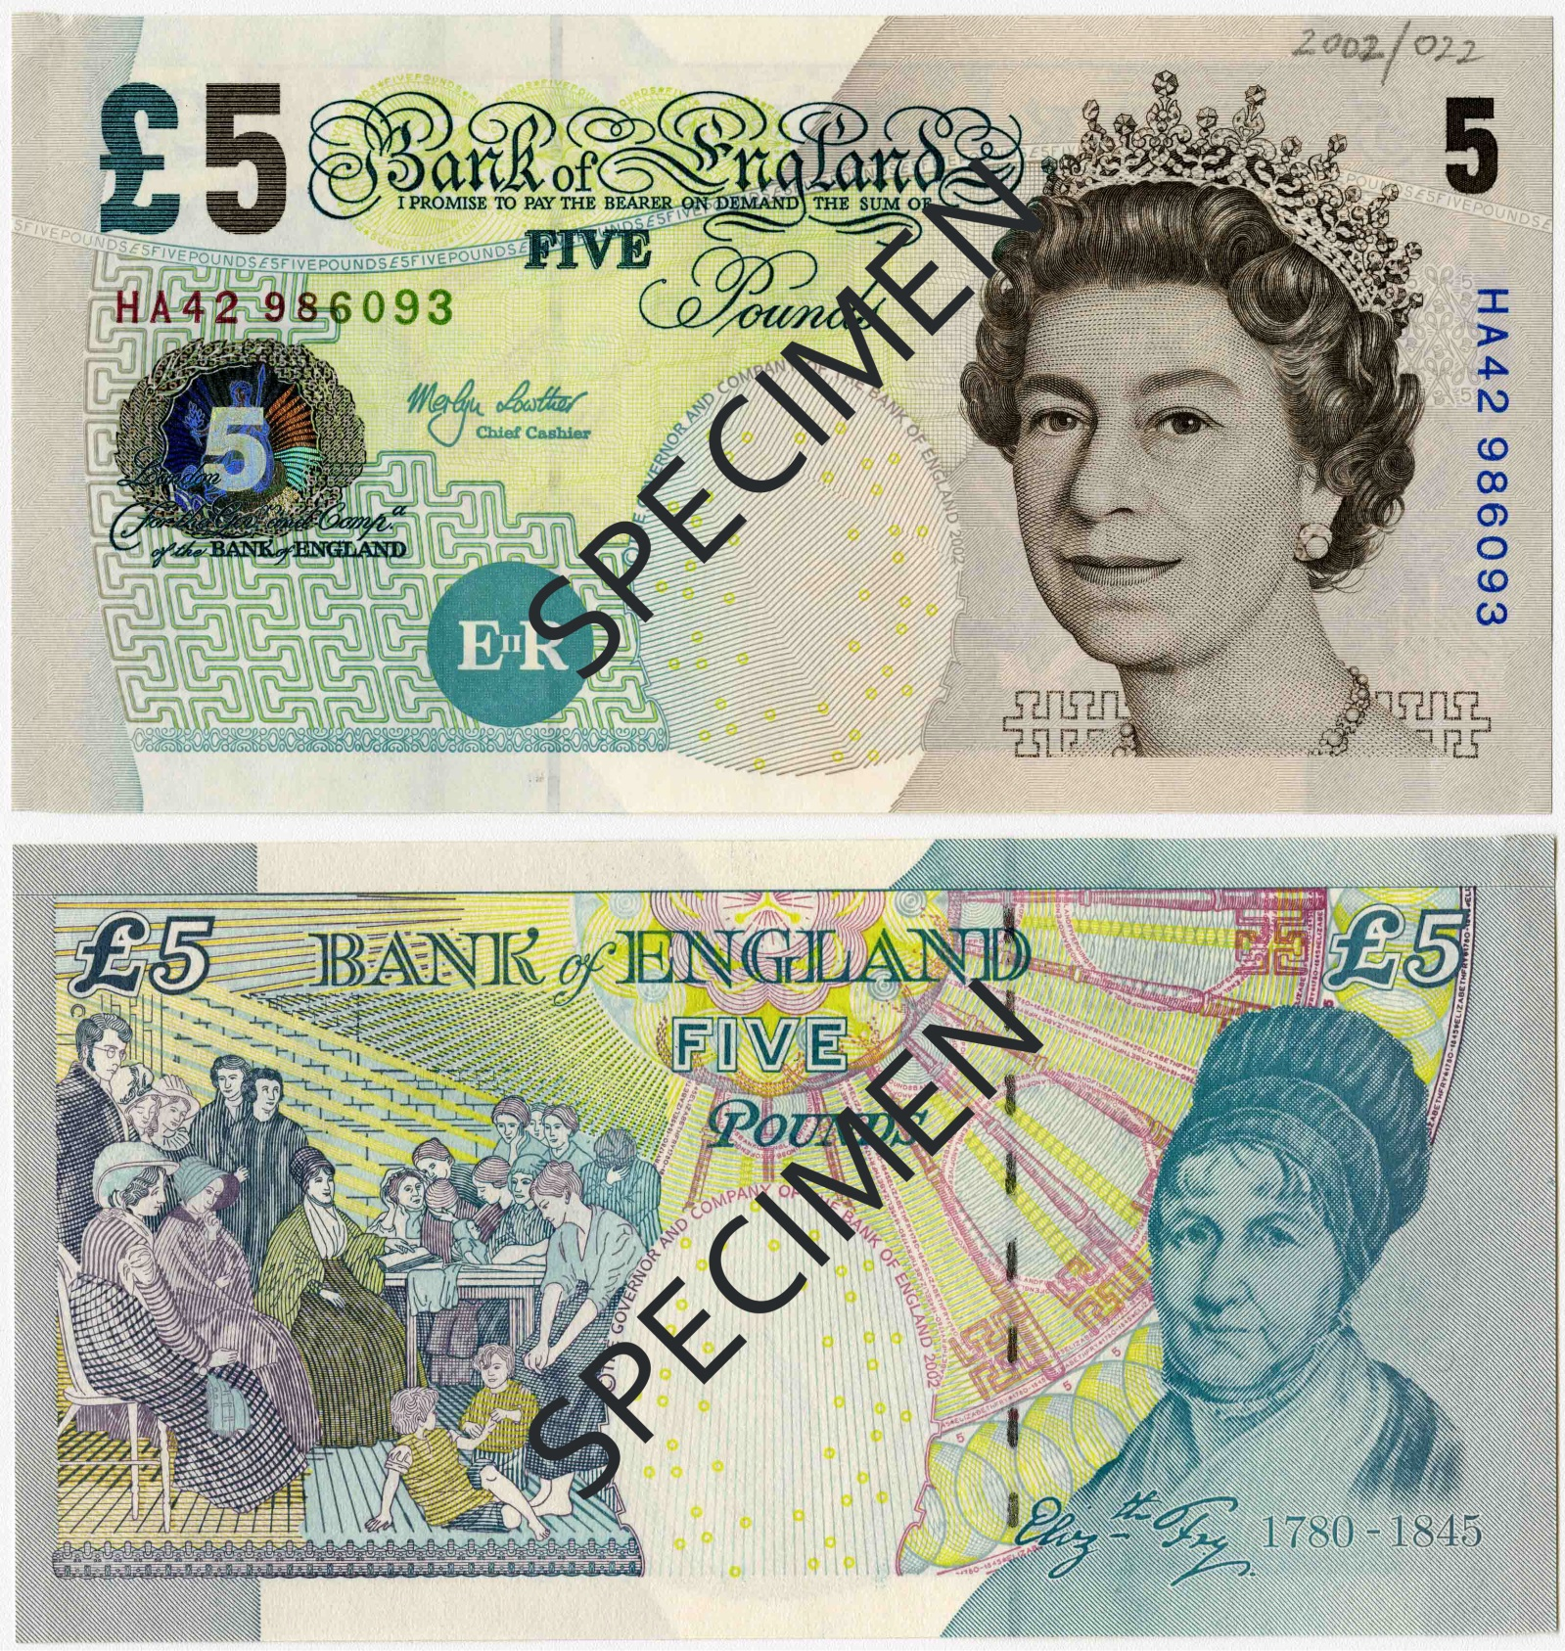
Elizabeth Fry was a reformer – that means she tried to change things to make them better. She was concerned about the conditions in women’s prisons, where women were poorly treated. She visited the prisons to improve conditions and set up lessons to teach the women how to sew so they could have a useful skill to work once they were released.
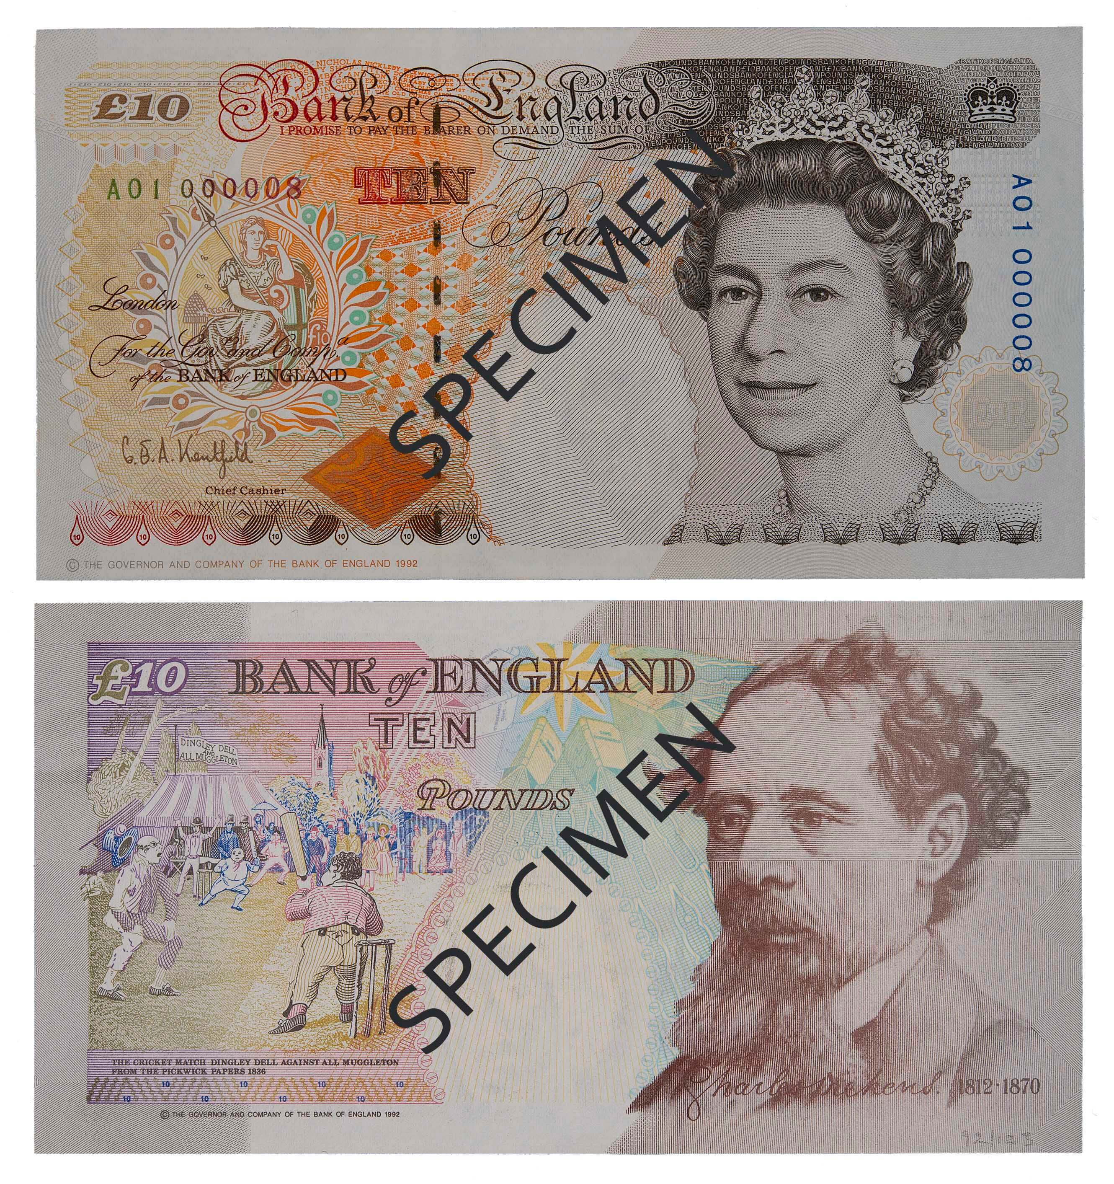
Charles Dickens was a famous author. He wrote many stories about the poor in England that encouraged people to think about how to show kindness to others and change the laws to make treatment better. You may have heard of some of his stories – including A Christmas Carol.
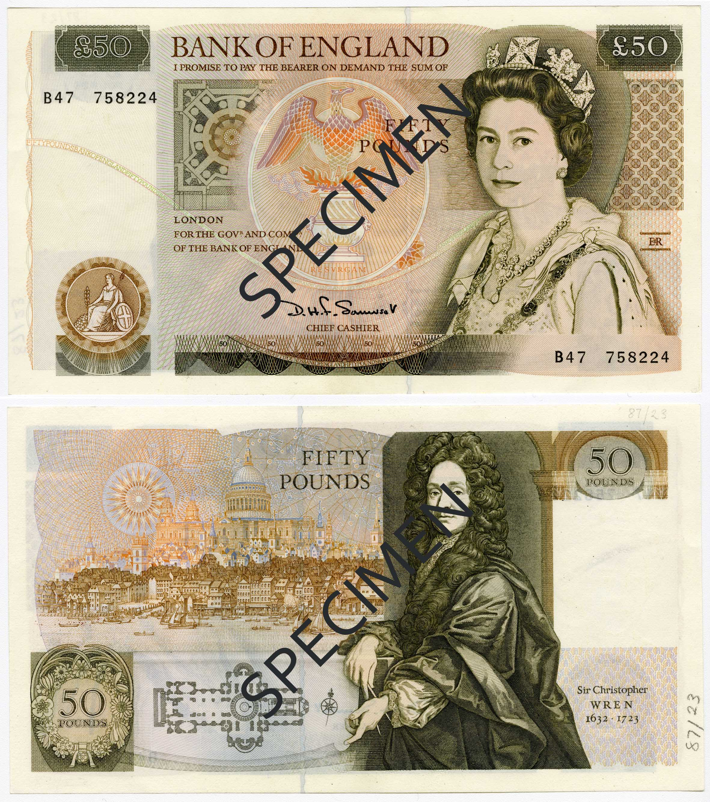
Christopher Wren was one of the architects who helped rebuild London after the Great Fire in 1666. His designs were very famous, including the new dome of St. Paul’s Cathedral which is shown on the note (and which you can still see today).
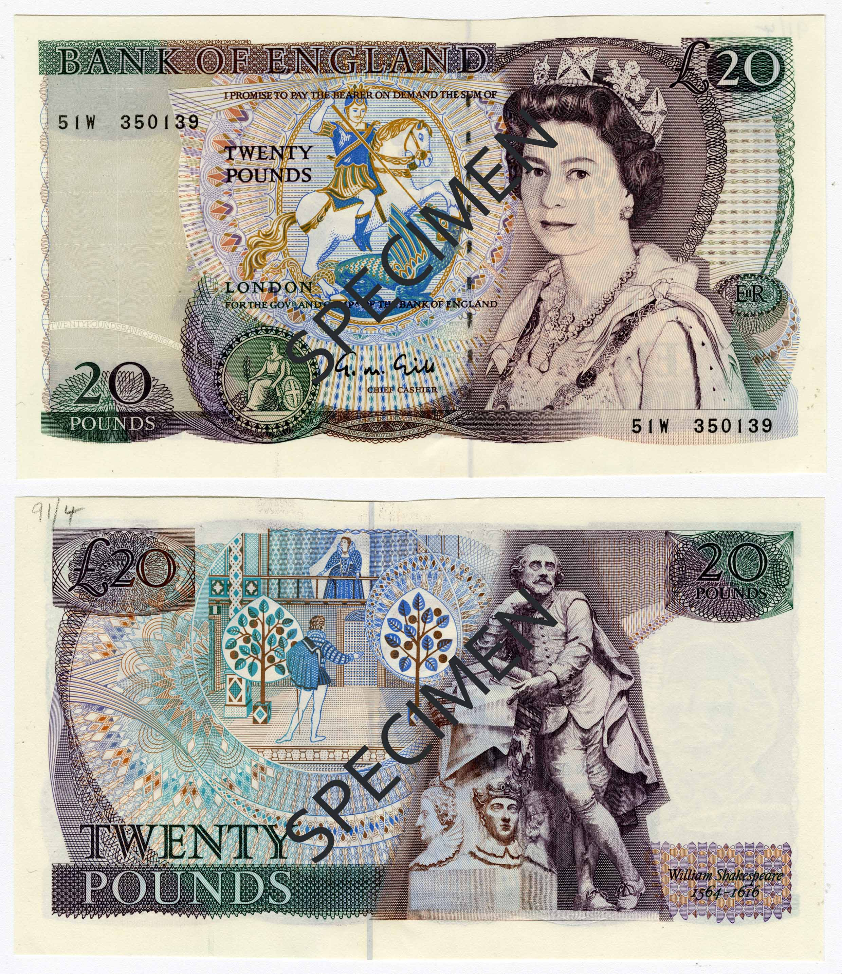
William Shakespeare wrote many plays during the reign of Queen Elizabeth I that were performed at the Globe Theatre. Shakespeare’s plays are incredibly famous because they show how people thought and spoke in the time he was writing, and also because they are still incredibly fun to see and perform in. One of his most famous plays is a love story called Romeo and Juliet. One scene from that play is shown on this old note.
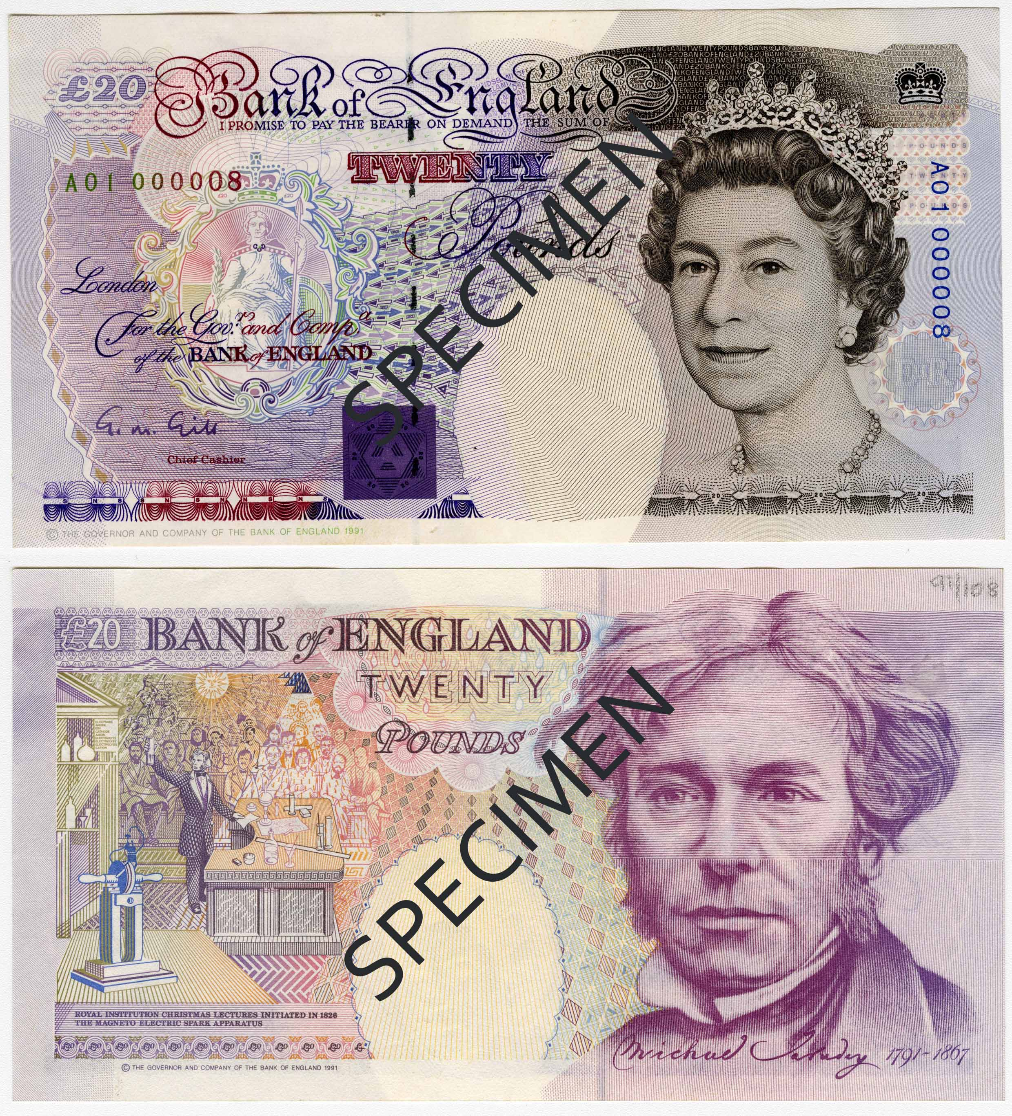
Michael Faraday was an English scientist in the Victorian era. Although not a skilled mathematician, Faraday explored a lot of scientific ideas and made amazing discoveries. He particularly explored and learned about electricity and magnetism, and his discoveries allowed people to use electricity safely and design machines that used it.
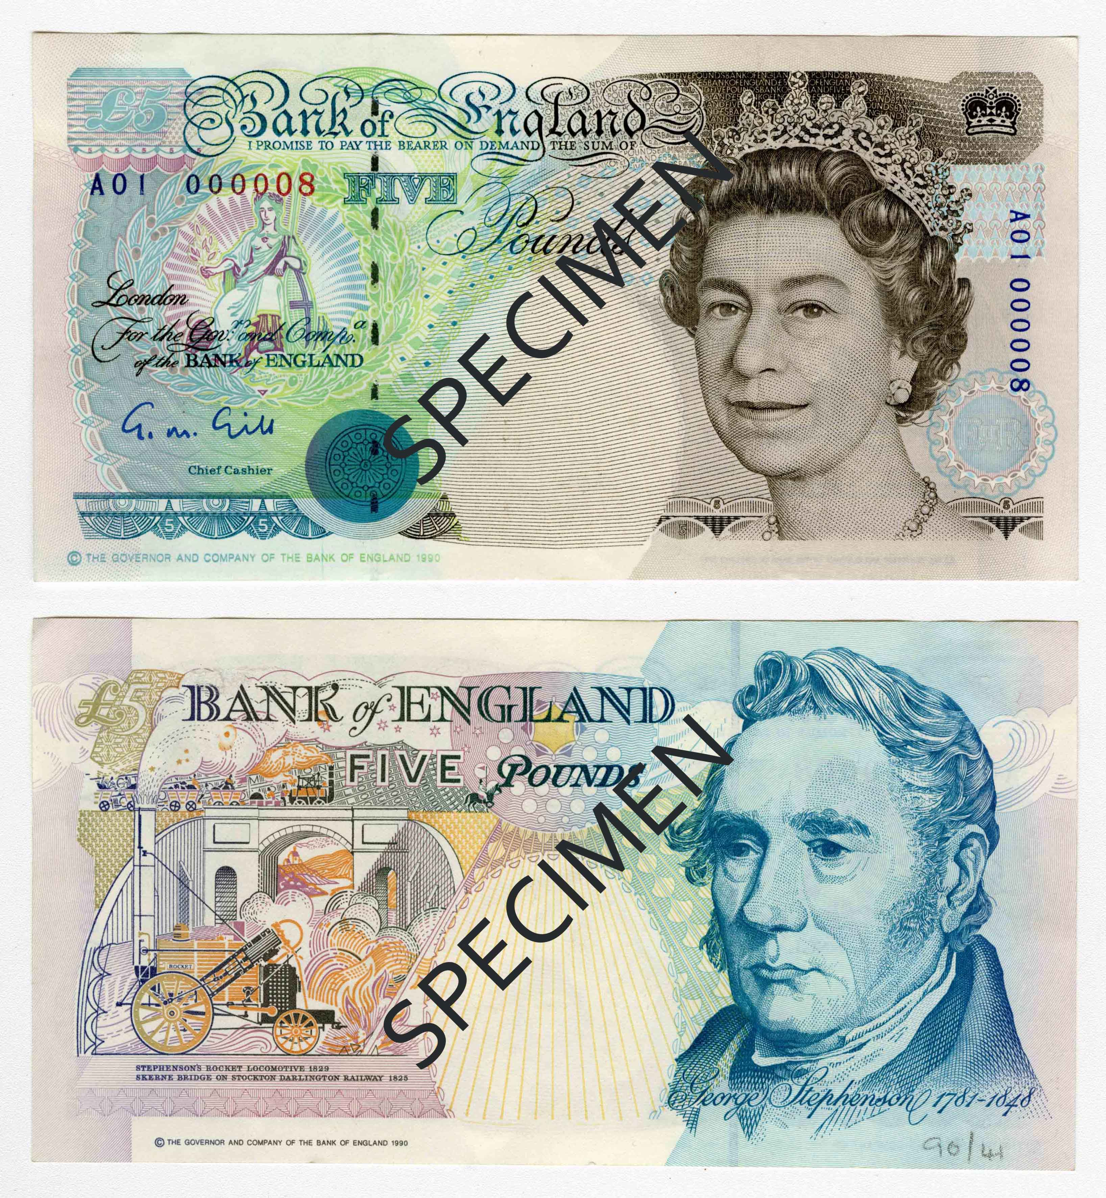

George Stephenson was an English engineer who worked especially on the use of steam engines. His designs and work encouraged the development of railways that transformed travel and transport. He was often nicknamed “Father of the Railways”.

Resource 2

Question | Answer
Who is on all of the banknotes? Why?
What sort of jobs did the people in the banknotes do?
What is similar about the people in the banknotes? (As a clue, one of them is the odd one out).
Can you think of ways to make the banknotes better?

Resource 3

The Summer of 1858, the Great Stink of London
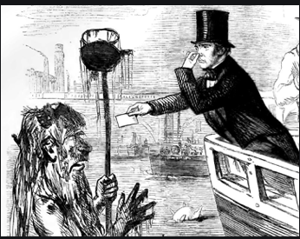
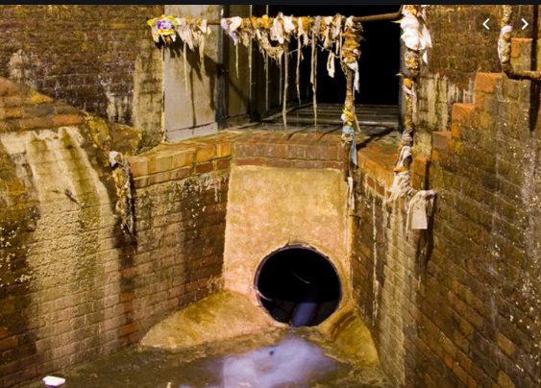

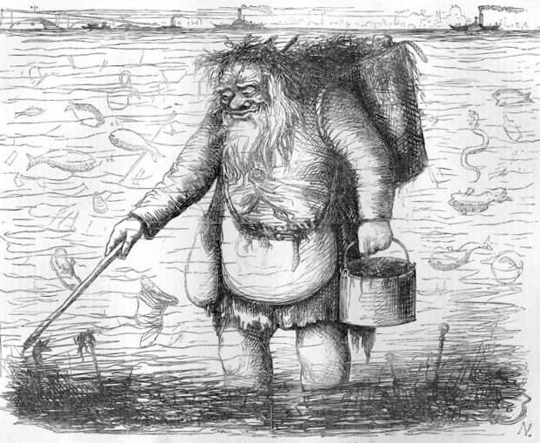

Filthy river, filthy river,
Foul from London to the Nore,
What are you but one vast gutter?
One tremendous common shore?

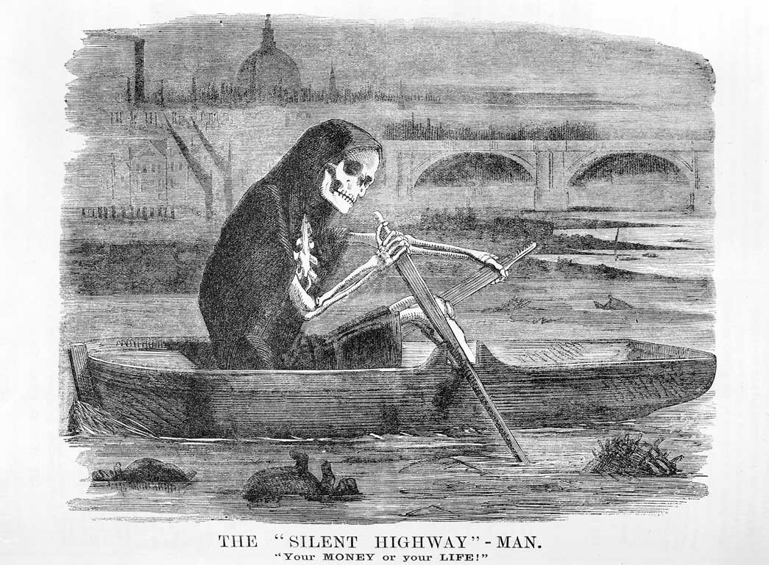

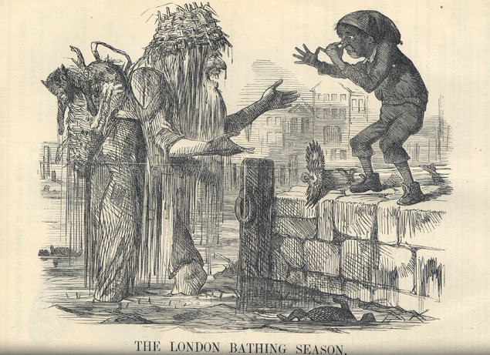

“He who drinks a glass of London water has literally in his stomach more creatures than there are men, women and children on the face of the globe.” Sydney Smith

“This noble river has become a terrible pool stinking of horror” Benjamin Disraeli

“The intense heat and stink had driven the MPs from those parts of Parliament which overlook the river. A few brave members, who wanted to investigate the problem, went into the library, but they were instantly forced to run away, each man with a handkerchief to his nose!” The Times newspaper

“We live in muck and filth. We aint got no privies, no dust bins, no water splies and no drain or suer in the whole place. If we fall ill, nothing can help us.” Letter from the Poor of London sent to The Times.

(ain’t – haven’t / privies – toilets / splies – supplies / suer – sewer)

“Near the bridges the toilet waste of London rolled up in clouds so thick that they could be seen at the surface of the river… the whole river was a real sewer” Michael Faraday, writing after seeing the Thames.

- What do you think the problem was?

- Why were people falling ill in London?

Resource 4

The Great Stink of 1858 caused Parliament to vote for someone to fix the problem. They chose the engineer, Joseph Bazalgette. Who designed a new sewer system for London; have a look at the sources below to see what kind of work happened.

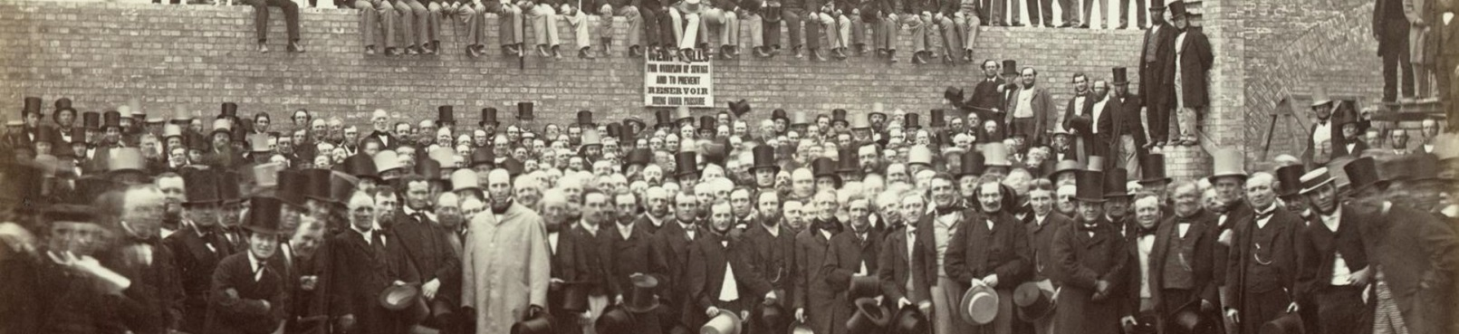

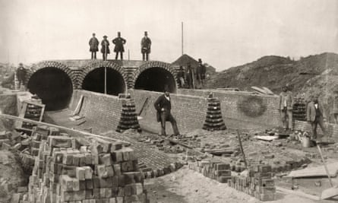

Work began on the system in 1859, and took twenty years to complete. Bazalgette’s building work cost around £3 million at Victorian prices (about £400 million today!).

They designed and built 82 miles of new tunnels, and used 318 million bricks to do it. The price of bricks rose, and the workers were paid 6 shillings a day (about £50).

In 1866 the system had already worked – no-one in London fell ill from cholera that year except in parts that weren’t connected to the sewers yet.

Bazalgette did not do all the work himself, but helped design and checked all of the plans himself. He also visited every connection between the old drains and his new sewers to check that no waste was escaping. He also found time to design lots of other Thames projects, including Battersea Bridge, Albert Bridge, Putney Bridge, and early plans for the Blackwall Tunnel
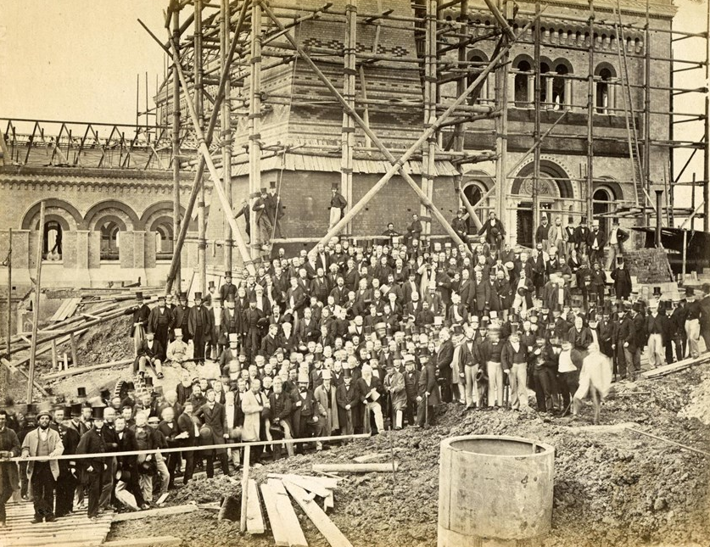
Workmen and engineers at one of Bazalgette’s new pumping stations

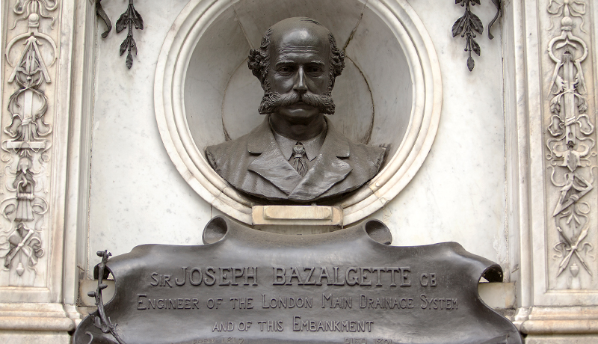

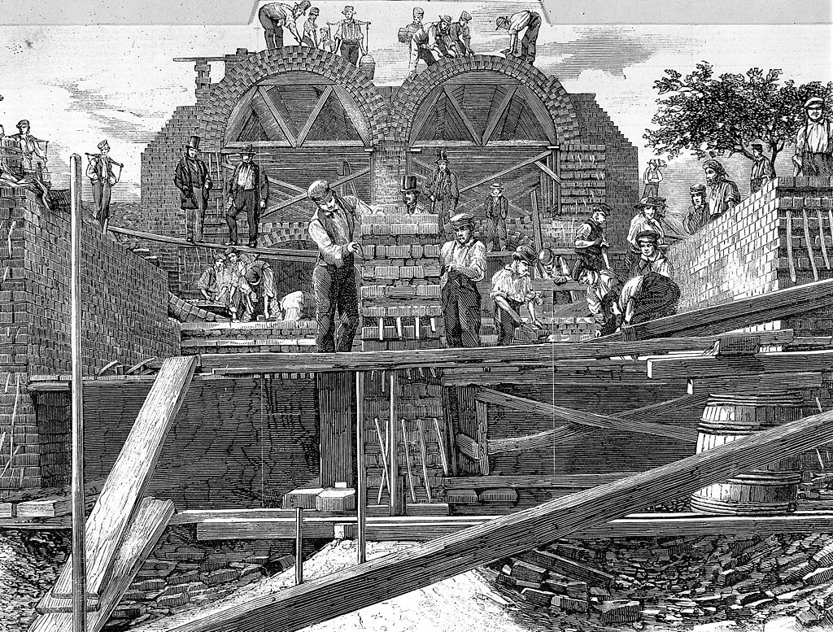

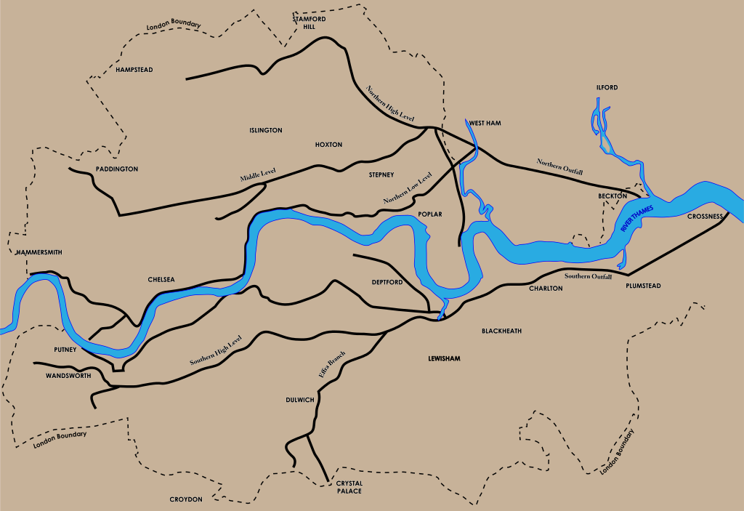
Map of Bazalgette’s sewer pipe system.

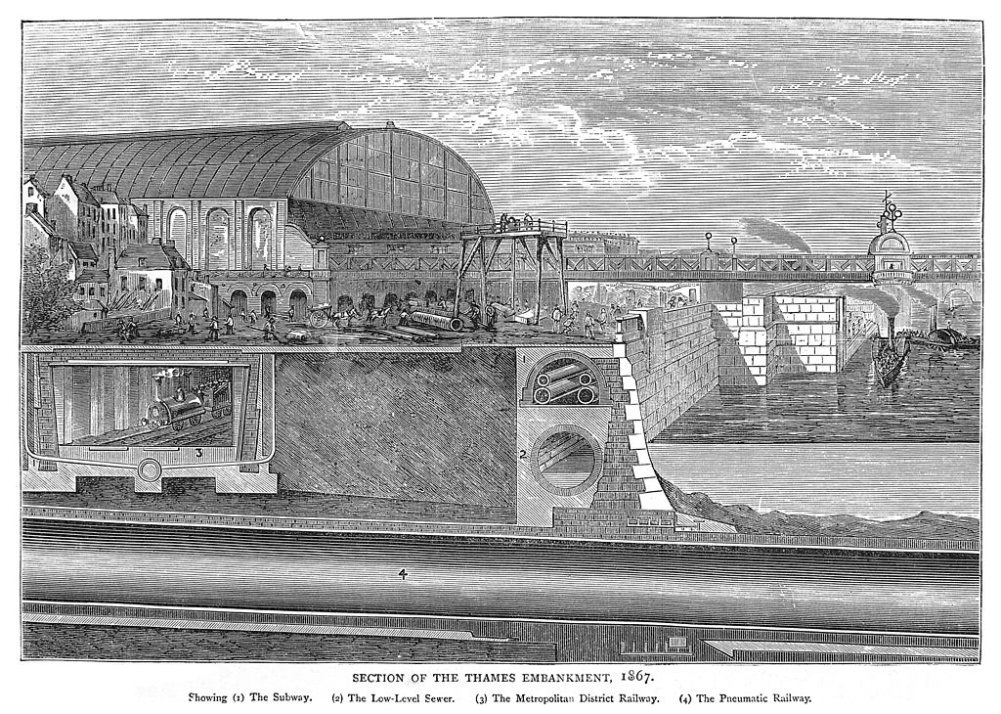

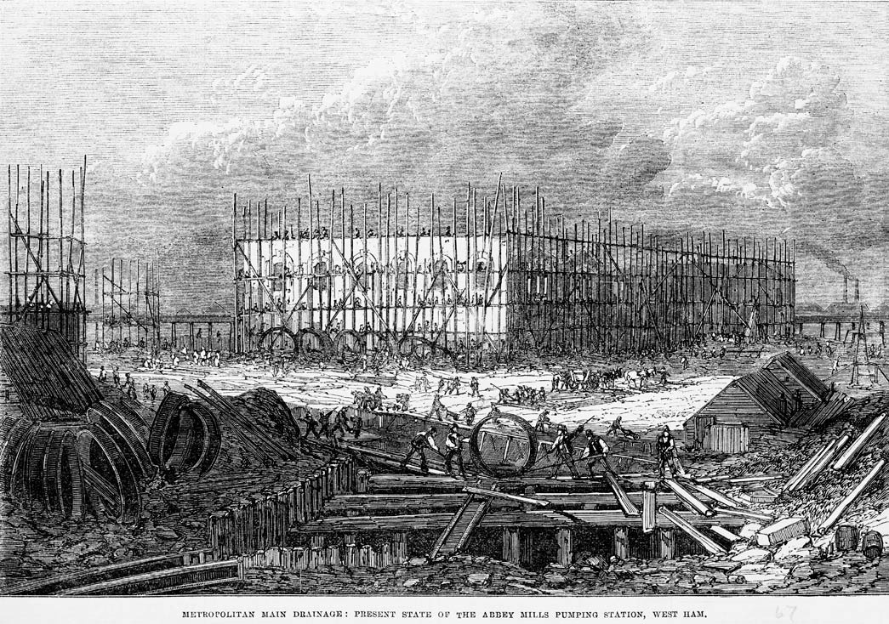
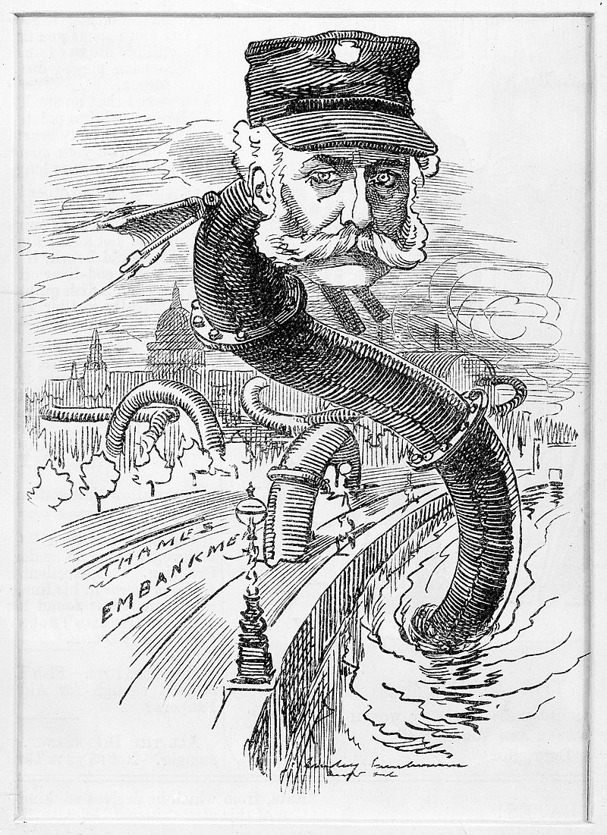
A funny newspaper picture showing Bazalgette as the “sewer pipe snake”!

Bazalgette also made a very important decision. He calculated how much pipework each person in London would need, and then said “Well, we're only going to do this once and there's always the unforeseen” – and doubled the size of the pipes to make sure more people could live in London without the problem happening again.

Bazalgette’s sewer system is still used today – only recently have new plans been needed to stop the bigger population of London swamping the Thames with poo again!

Resource 5

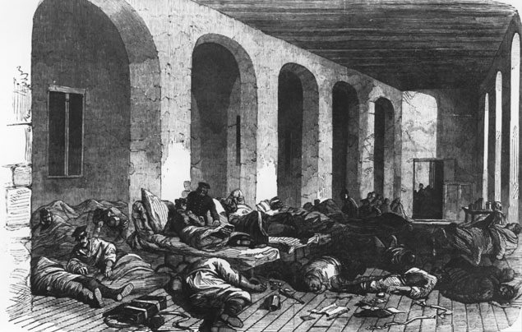

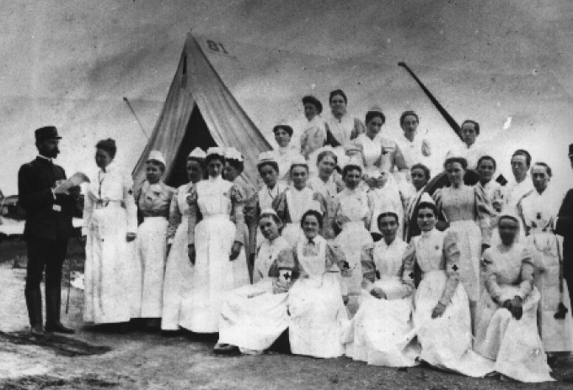

‘The men were kept in rooms without blankets or decent food. Unwashed, they were still wearing their army uniforms that were stiff with dirt and blood.’ Florence Nightingale describing the hospital in her diary.

'All were swarming with rats, huge insects crawling all about their bodies and clothes. Many were covered with mud, dirt, blood and gunpowder stains. Several were very sick and lying on the floor. The sight was a terrible one and such as I had never before witnessed...

'There have been no arrangements for this hospital. Until some hours after the arrival of the men there were no stores, no medical staff nor any food for the men to eat. During this afternoon I had to treat the wounds and wants of 74 helpless men all on my own.' Army Surgeon Henry Bellew describing the hospital.

Resource 6

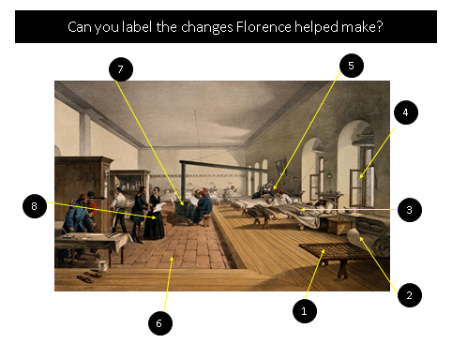

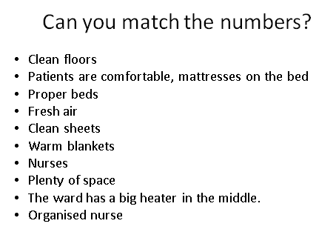

“She is a "ministering angel" without any exaggeration in these hospitals, and as her slender form glides quietly along each corridor, every poor fellow's face softens with thankfulness at the sight of her. When all the medical officers have gone to bed for the night and silence and darkness have settled down upon those miles of sick in their beds, she may be seen alone, with a little lamp in her hand, making her rounds.” The Times report on Crimea

Florence was not popular with everyone. Some thought she had taken charge when others should have been doing the work, and when she returned to England she spent the rest of her life using Maths to work out how to make hospitals better. She used charts to show how people had fallen ill, like this one:

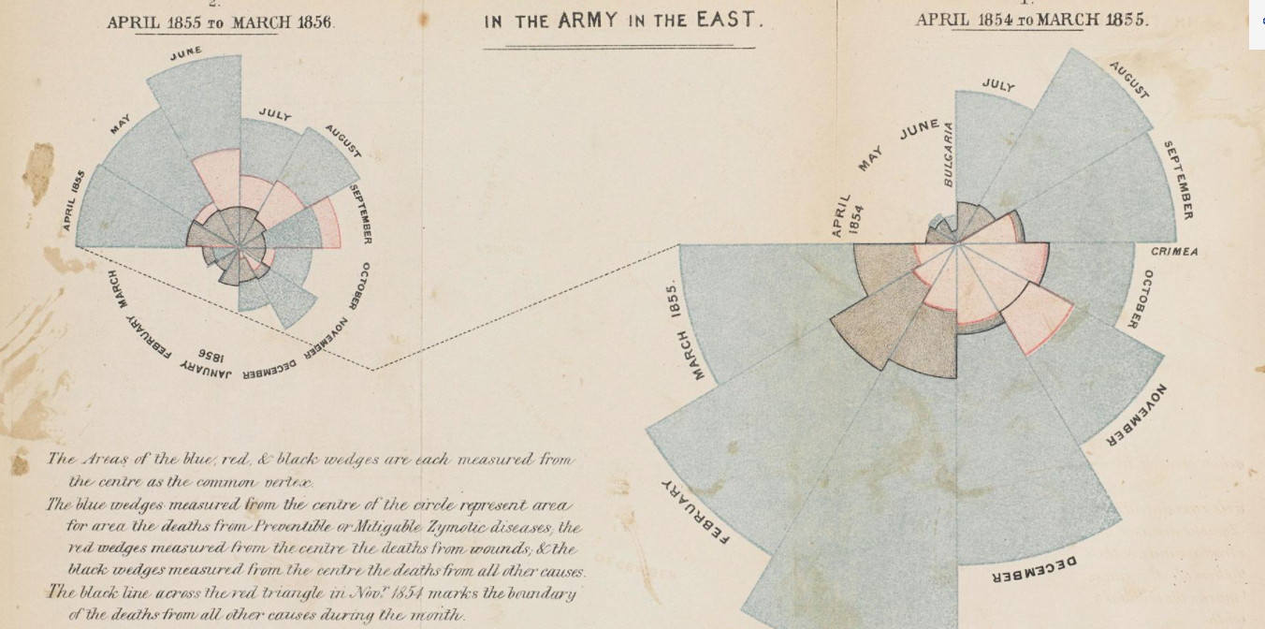

Resource 7

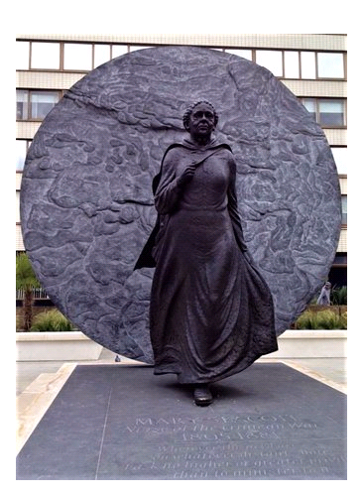
Dear ________________,

I am writing to you to tell you why _____________________________________________.

From _______________________
Resource 8

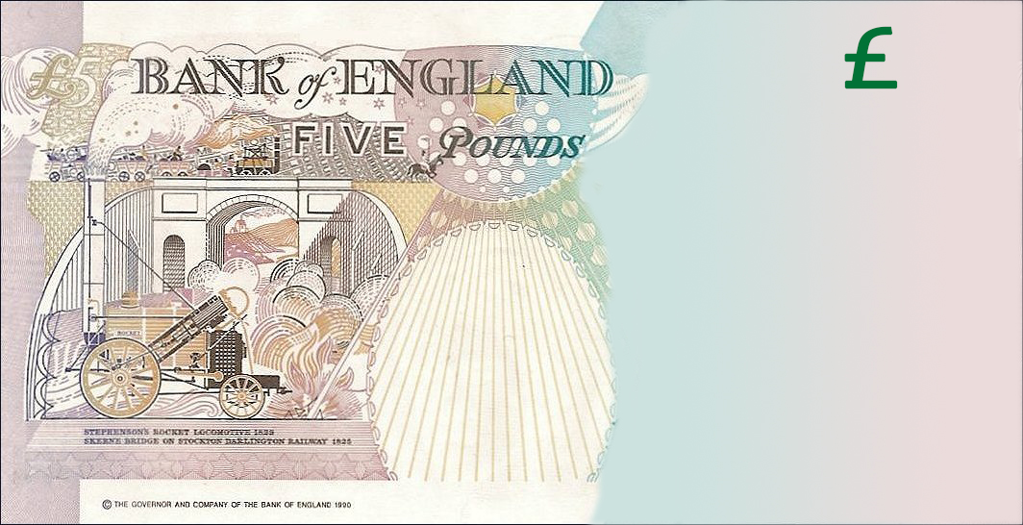

I chose __________________________________ to be on my banknote.

I chose this person because:

